Control System Checkout using LabVIEW

jUNE 3 TO 28, 2013

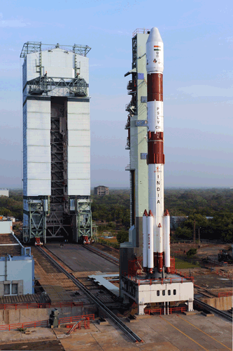

**Done By,**

**Adarsh Suresh**

**Ajith AV**

**Sanjay Sanjeev**

**J Vishak**

**Acknowledgement**

I thank Head of Stage Checkout System and Operation Division (SCOD) Mr. C Chandrasekaran, Vikram Sarabhai Space Center (VSSC) Thiruvananthapuram for permitting me to do internship in the prestige organisation. I would also like to thank Mr. Saju S for being my guide during the project. I would also like to convey my gratitude to all the staff and the management of VSSC Thiruvananthapuram for the wonderful time I had in the industry.

Contents

ABOUT VIKRAM SARABHAI SPACE CENTER 4

History 4

Various ISRO Centers 4

ABSTRACT 5

INTRODUCTION 6

SYSTEM REQUIREMENTS 6

STEP RESPONSE 6

FREQUENCY RESPONSE 6

SYSTEM ANALYSIS 7

SYSTEM STUDY 7

CONTROL SYSTEM 7

STEP AND FREQUENCY RESPONSE 8

EXISTING SYSTEM 10

PROPOSED SYSTEM 11

SYSTEM DESIGN 11

BLOCK DIAGRAM 11

LabVIEW 13

ANALOG TO DIGITAL CONVERTOR 13

COMPUTATION OF PARAMETERS 15

IMPLEMENTATION 17

LabVIEW VI 17

SUBVI EXPLANATION 19

REFERENCE 21

# ABOUT VIKRAM SARABHAI SPACE CENTER

VSSC is the lead Centre for development of satellite launch vehicles and associated technologies. The Centre pursues active research and development in a host of distinct technology domains like aeronautics, avionics, and composites with a view to achieve self-reliance in the high tech realm of launch vehicle technology.

The centre had its beginnings as the Thumba Equatorial Rocket Launching Station (TERLS) in 1962. It was renamed in honour of Dr. Vikram Sarabhai, the father of the Indian space program. VSSC is an entirely indigenous facility working on the development of sounding rockets, PSLV, GSLV.

## History

Situated near the northern boundary of Thumba Equatorial Rocket Launching Station (TERLS),  a  few meters from the coastline,  St Mary Magdalene Church,   lined with high-tech artifacts and visuals  speak, the tell tales on the birth of Indian Space Programme.

It was in this church that the first rocket systems were assembled and integrated in 1962. The Bishop House, which is situated close to the church, functioned as the office of the newly set up rocket launching station. The office of the Director of TERLS was housed here.  As the pace of the scientific activity gathered momentum, new projects came into being which necessitated the construction of new buildings. The first in the line were the Control Centre and then the R&D complex on the Veli Hills, all of which relegated the church building into the background.

## Various ISRO Centers

* Vikram Sarabhai Space Center (VSSC), Trivandrum.
* ISRO Satellite Center (ISAC), Bangalore.
* Satish Dhawan Space Center (SDSC) SHAR, Sriharikota
* Liquid Propulsion Systems Center (LPSC), Trivandrum
* Indian Institute of Space Science and Technology (IIST), Trivandurm
* Master Control Facility (MCF), Hasan

# ABSTRACT

The main aim of creating Control system checkout using LabVIEW is to provide an application to test and scrutiny the control system.  This is a testing software which helps us to analyze the various parameters that controls the system. The existing systems are costly and bulky. As the requirement for our software is limited to 20 Hz, it is not necessary to use a system which has a range of 40K Hz. So it is better to use LabVIEW software which meets our requirement. As the hardware used in the system are very costly, the testing must be done in a virtual instrument rather than directly applying in the real instrument. So there is a need for software to be developed which helps us to test and analyze the real time attributes of the system. The developed application will be user friendly, decreases manual effort and also provides us with different testing options according to our requirement.

# INTRODUCTION

Control systems are based on feedback control loops which are implemented to increase dynamical performance or precision of scientific and industrial equipment. So the control systems should be tested and analyzed before it is applied in real life. Control system testing has been done using real instruments itself which causes a lot of damage to the instruments. So we are developing a software for the automated testing of control systems using LabVIEW. The basic principle of this system is to take into account actual measurement values in order to compute appropriate actuations that adjust the operational conditions to meet given requirements.

Acquisition of measurements and modification of actuations are tasks carried out by LabVIEW software and DAQ. In our testing system we give the system a step input and sweep frequency input for which the system gives a response and this response is analyzed using various measures such as rise time calculation, pre and post transition under and over shoot. In case of frequency we analyze phase and magnitude response.

In step response, we calculate the rise time, undershoot, over shoot of pre and post transition. From a practical standpoint, knowing how the system responds to a sudden input is important because large and possibly fast deviations from the long term steady state may have extreme effects on the component itself and on other portions of the overall system dependent on this component.

# SYSTEM REQUIREMENTS

The main requirement of the software is to analyze step response and frequency response of the control system.

## STEP RESPONSE

* The input wave should be plotted in a graph.
* The parameters should be read from the database based on the test name selected by the user.
* User should be able to select the time period for the calculation of parameters.
* Region of calculations should be displayed in a graph.
* Calculated data should be stored into a file with time stamp as its filename.

## FREQUENCY RESPONSE

* The parameters should be read from the database based on the test name selected by the user.
* The channels must be selected by the user.
* Two channels are needed. One is for stimulus channel and other is for response channel.
* Magnitude Vs Frequency and Phase Vs Frequency should be plotted in a graph.
* Magnitude and Phase for each frequency must be written into a file with time stamp as its file name.

# SYSTEM ANALYSIS

## SYSTEM STUDY

The various concepts required to build this software are of control systems, step response and frequency response. They are as follows.

## CONTROL SYSTEM

A control system is a device or a set of devices that manages the behavior of other devices or systems. Industrial control systems are used in industrial production.

The term control system may be applied to the essential manual controls that allow an operator to close and open a hydraulic press.

There are two common classes of control systems.

* Open control system
* Closed control system.

An automatic sequential control system may trigger a series of actuators in the correct sequence to perform a particular task.

In the case of linear feedback systems, a control loop, control algorithms and actuators is arranged in a fashion to perform a task.

**In open loop control**, there is some sort of input signal (digital or analog), which then passes through amplifiers to produce the proper output, and is then passed out of the system. *Open loop controls have no feedback.*

In closed loop control, the system is self-adjusting. Data does not flow one way, it may pass back from a specific amplifier (such as velocity or position) to the start of the control system, telling it to adjust itself accordingly. Many physical systems are closed loop control.

Open and closed control systems can be diagrammatically represented as follows.

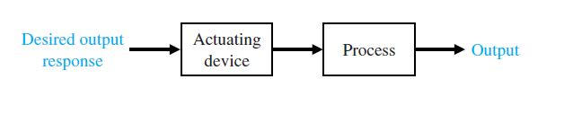

Figure 1: Open Control System

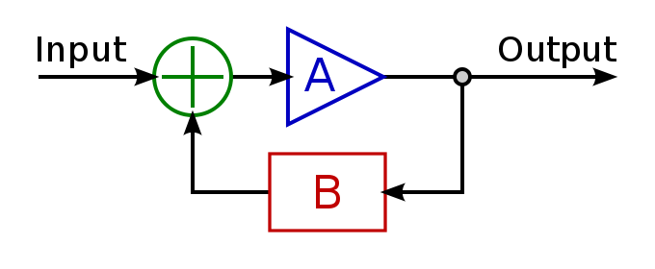Here, A is an actuator and B is a feedback.

Figure 2: Closed Control System

Here it checks for errors. If no errors are present, next input will be provided. Otherwise, the error will be corrected before going to the next input.

## STEP AND FREQUENCY RESPONSE

**Step Response**

Step response is the time behavior of the outputs of a general system when its inputs change from zero to one in a very short time.

Characterized by the following:

* Rise Time
* Over shoot
* Under shoot
* Settling time

Rise Time

In control theory, for overdamped systems, rise time is commonly defined as the time for a waveform to go from 10% to 90% of its final value. Rise time is an analog parameter of fundamental importance in high speed electronics, since it is a measure of the ability of a circuit to respond to fast input signals.

Overshoot and Undershoot

In electronics, **overshoot** refers to the transitory values of any parameter that exceeds its final (steady state) value during its transition from one value to another. An important application of the term is to the output signal of an amplifier.

**Undershoot** refers to the transitory values of any parameter goes below its final state value during its transition from one value to another.

A circuit is designed to minimize rise time while containing distortion of the signal within acceptable limits.

1. Overshoot represents a distortion of the signal.
2. In circuit design, the goals of minimizing overshoot and of decreasing circuit rise time can conflict.
3. The magnitude of overshoot depends on time through a phenomenon called *"damping."* See illustration under step response*.*
4. Overshoot often is associated with settling time, how long it takes for the output to 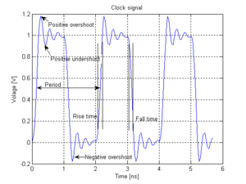reach steady state.

Figure 3: Overshoot and Undershoot

Settling Time

The **settling time** of an amplifier or other output device is the time elapsed from the application of an ideal instantaneous step input to the time at which the amplifier output has entered and remained within a specified error band, usually symmetrical about the final value.

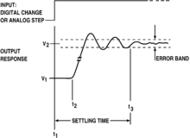Settling time depends on the system response and time constant.

Figure 4: Settling Time

*Settling time is the time required for an output to reach and remain within a given error band following some input stimulus.*

**Frequency Response**

Frequency Response is the quantitative measure of the output spectrum of a system. It is a measure of magnitude and phase of the output as a function of frequency, in comparison to the input. This can be explained in a much simple way : If a sine wave **Asin(wt)** is injected into a system at a given frequency, a linear system will respond at that same frequency with a certain magnitude and a certain phase angle relative to input. That is we will get the output as **Bsin(wt+ (phi) ).** Also, for a linear system, doubling the amplitude of the input will double the amplitude of the output.

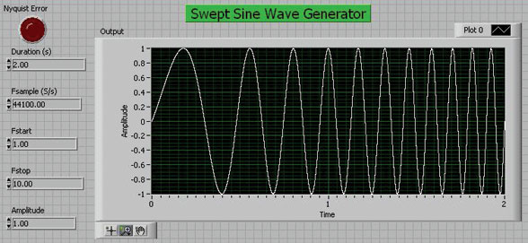The input wave of a frequency response will be like this.

Figure 5: Swept Sine Wave generator

The output of this input wave will be a Broad plot - A plot of Magnitude, phase vs frequency.

The frequency response is characterized by the **magnitude**of the system’s response, typically measured in decibels dB. It is also characterized by the **phase**measured in radians or degrees.

Estimating the frequency response for a physical system generally involves exciting the system with an input signal, measuring both input and output time histories, and comparing the two through a process such as the Fast Fourier Transform (FFT).

## EXISTING SYSTEM

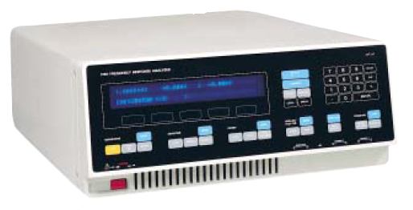

The device under test is stimulated by a sine wave and the response analyzed at one, two or more points in the system. These responses are then correlated with the stimulus to determine the amplitude and phase relative to the generator. The ratio of the two measured signals can then be used to provide the system transfer function.   
 The existing system has a range of 10μHz to 65 kHz which is not necessary for our purpose. We need a range of values up to a maximum of 20Hz. So 65 kHz is a very large value and hence using this instrument is a waste of money. Also this instrument is bulky.

## PROPOSED SYSTEM

The proposed system is an automated testing application which is used for reading the responses from a control system which is inside a launch vehicle. This application allows us to test the step and frequency responses in a virtual instrument first before testing in a real instrument. In real life, once the testing is started, it may or may not be stopped. So we first try in a computer based application.

# SYSTEM DESIGN

## BLOCK DIAGRAM

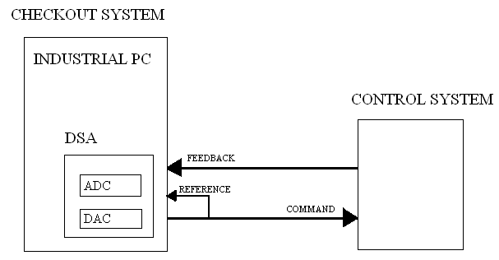

NI 4461 card block diagram.  
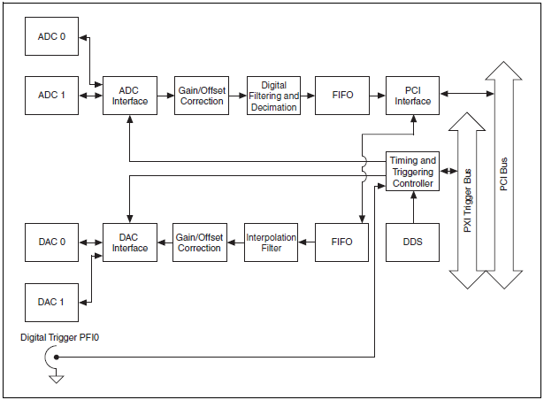

The NI 4461 devices feature two analog input and two analog output channels with gain and attenuation. The NI 446*x* analog input channels feature sampling rates up to 204.8kS/s. it has also anti-aliasing filters.

The transfer function H(f) can be determined using the formula. The transfer function gives the gain and phase versus frequency of a network and is typically computed as

## 

Where A is the stimulus signal and B is the response signal.

The two-sided cross power spectrum of two time-domain signals A and B is computed as

## LabVIEW

The project was based on National Instruments (NI) software called LabVIEW which is **Laboratory Virtual Instrument Engineers Workbench.**

Figure 6: LabVIEW

LabVIEW works in all operating systems environment: Linux, Windows, and UNIX.

LabVIEW is a graphical programming platform that helps engineers scale from design to test and from small to large systems. It offers unprecedented integration with existing legacy software, IP, and hardware while capitalizing on the latest computing technologies. LabVIEW provides tools to solve today’s problems—and the capacity for future innovation—faster and more effectively.

LabVIEW is used to build any measurement or control application based software in dramatically less time. It integrate graphical, text-based, and other programming approaches within a single environment to efficiently create custom software solutions

## ANALOG TO DIGITAL CONVERTOR

An **analog-to-digital converter** – ADC - is a device that converts a continuous physical quantity (usually voltage) to a digital number that represents the quantity's amplitude.  The conversion involves quantization of the input, so it necessarily introduces a small amount of error. The inverse operation is performed by a digital-to-analog converter (DAC). Instead of doing a single conversion, an ADC often performs the conversions periodically for samples. The result is a sequence of digital values that have converted a continuous-time.

An ADC is defined by its **bandwidth** - the range of frequencies it can measure and its **signal to noise ratio** - how accurately it can measure a signal relative to the noise it introduces.  The actual bandwidth of an ADC is characterized primarily by its sampling rate. The dynamic range of an ADC is influenced by many factors, including the resolution (the number of output levels it can quantize a signal to), linearity and accuracy (how well the quantization levels match the true analog signal) and jitter (small timing errors that introduce additional noise).

**SPECIFICATIONS**

* **Resolution**

The resolution of the converter indicates the number of discrete values it can produce over the range of analog values. The values are usually stored electronically in binary form.  The resolution is usually expressed in bits.  For example, an ADC with a resolution of 8 bits can encode an analog input to one in 256 different levels, since 28 = 256. The values can represent the ranges from 0 to 255 (i.e. unsigned integer) or from −128 to 127 (i.e. signed integer), depending on the requirement.

 The minimum change in voltage required to guarantee a change in the output code level is called ****the least significant bit (LSB) voltage. The resolution *Q* of the ADC is equal to the LSB voltage.

*M* is the ADC's resolution in bits and *E*FSR is the full scale voltage range (also called 'span'). *E*FSR is given by

**EFSR = V High – V Low**

* **Response Type**

Most ADCs are linear types. The term *linear* implies that the range of input values has a linear relationship with the output value.

Some convertors had logarithmic response.

* **Accuracy**

Accuracy refers to the closeness of the value to the required value.

An ADC has several sources of errors.  **Quantization error and non-linearity** are intrinsic to any analog-to-digital conversion. There is also a so-called *aperture error.* These errors are measured in a unit called the least significant bit (LSB).

For example, an eight-bit ADC, an error of one LSB is 1/256 of the full signal range, or about 0.4%

**Quantization Error:** Quantization error (or quantization noise) is the difference between the original signal and the digitized signal.

**Non-linearity Error:** ADCs suffer from non-linearity errors caused by their physical imperfections, causing their output to deviate from a linear function of their input.

* **Sampling Rate**

The analog signal is continuous in time and it is necessary to convert this to a flow of digital values. It is therefore required to define the rate at which new digital values are sampled from the analog signal. The rate of new values is called the *sampling rate* or *sampling frequency* of the converter.

* **Aliasing**

ADCs work by sampling their input at discrete intervals of time.  If the input signal is changing much faster than the sample rate, then this will not be the case, and spurious signals called *aliases* will be produced at the output of the DAC. The frequency of the aliased signal is the difference between the signal frequency and the sampling rate. For example, a 2 kHz sine wave being sampled at 1.5 kHz would be reconstructed as a 500 Hz sine wave. This problem is called *aliasing*.

To avoid aliasing, the input to an ADC must be low-pass filtered to remove frequencies above half the sampling rate. This filter is called an ***anti-aliasing filter*.**

* **Precision**

The **precision**of a measurement system, also called reproducibility or repeatability, is the degree to which repeated measurements under unchanged conditions show the same results

## COMPUTATION OF PARAMETERS

* **Computation of Rise Time**

The concept behind computation of Rise Time is as follows.

When we get an array of inputs, perform the following steps.

* Find the maximum and minimum element from the array – **max** and **min.**
* Find the difference between maximum and minimum value. Store it in **value**
* Find 10% of **value.** Store it as **val.**
* Compute **max-val** and **min+val.**
* Compute **indexOf(max-val) – indexOf(min+val).**

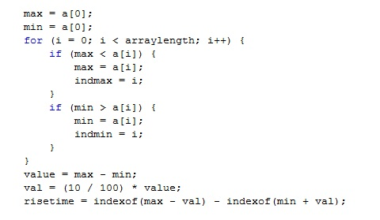The program is as follows.

* **Computation of Bandwidth**

Bandwidth describes the frequency range in which the input signal can pass through the analog front end with minimal amplitude loss - from the tip of the probe or test fixture to the input of the ADC. Bandwidth is specified as the frequency at which a sinusoidal input signal is attenuated to 70.7% of its original amplitude, also known as the -3 dB point.

For example, if you input a 1 V, 100 MHz sine wave into high-speed digitizer with a bandwidth of 100 MHz, the signal will be attenuated by the digitizer’s analog input path and the sampled waveform will have an amplitude of approximately 0.7 V.

* 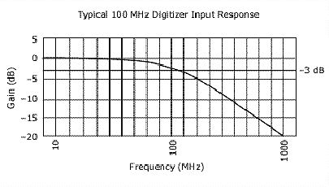**Computation of Sampling Rate**

Figure 7: Bandwidth

The sampling rate should be greater than twice the highest frequency of the measured signal.

**Sample rate > 2 * highest frequency component of the measured signal**

* **Computation of Swept Sine Wave generator**

The variables used in the program has their own original meaning.

* The loop must run for a total of **no_of_cycles * sampling_rate * (final_frequency – initial_frequency).**
* For one frequency, it should run for the **sampling_rate** times.
* Value is computed as **A*sin(2*pi*i*t)** where **i** is the frequency and **t** is the time.
* It should compute for each time for each samples in that particular frequency.
* So we calculated as **t = t + (1 / sampling rate)**

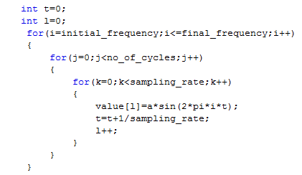The program is as follows.

# IMPLEMENTATION

## LabVIEW VI

**1.Frequency Response – Front Panel**

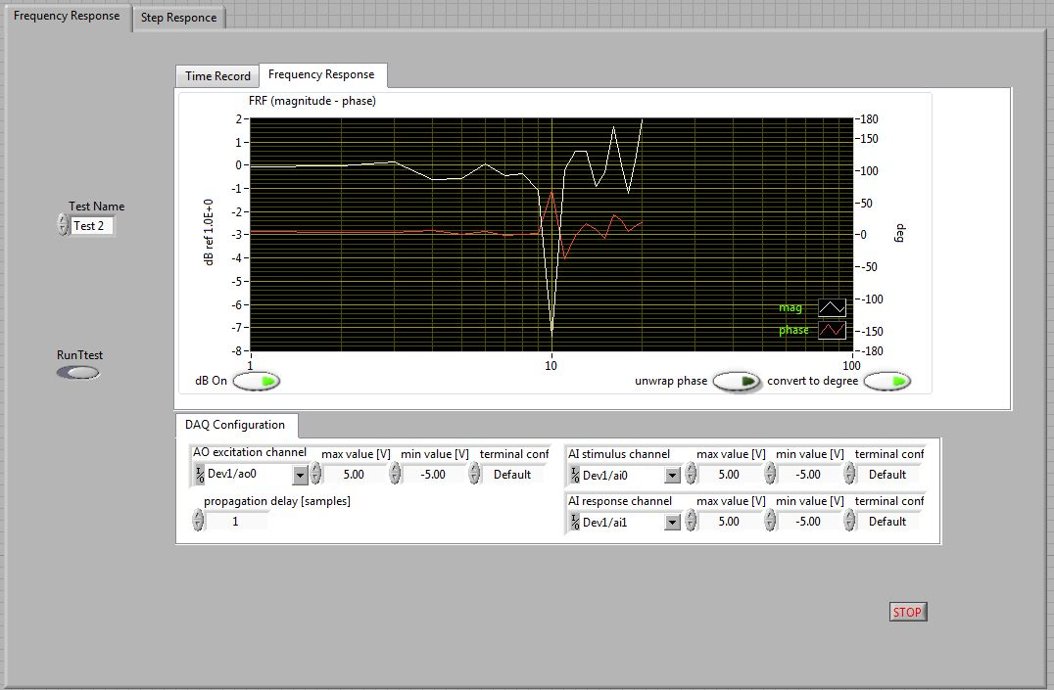

**2.Frequency Response – Block Diagram**

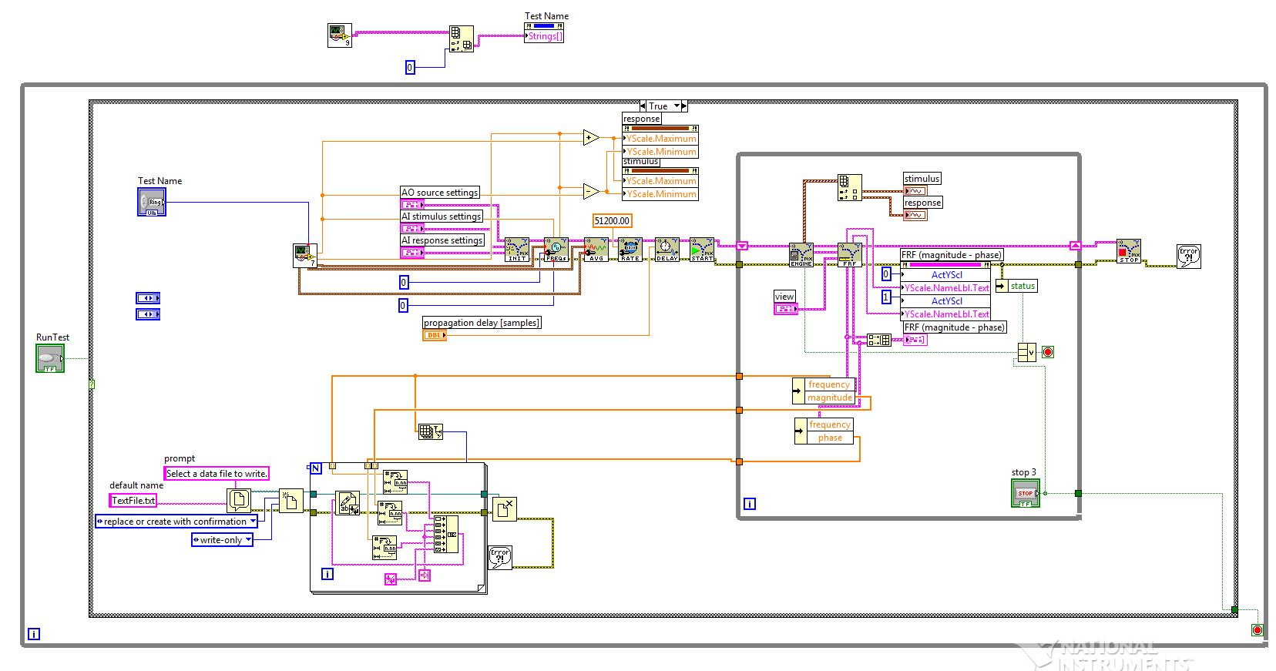

**3.Step Response – Front Panel**

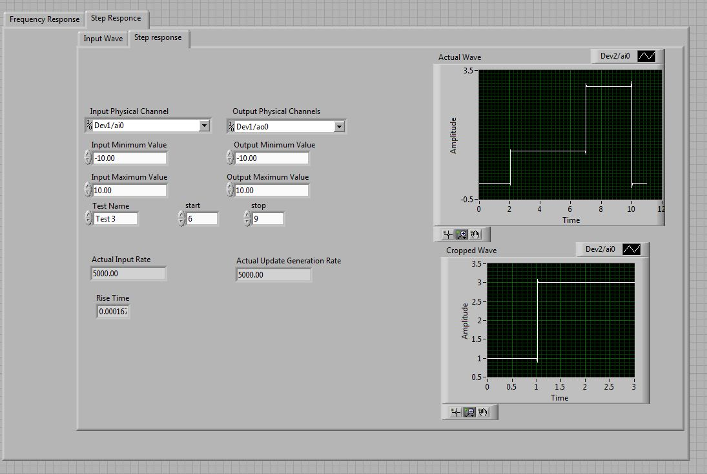

**4.Block Diagram – Input Wave**

## input wave.JPG

**5.Step Response – Block Diagram**

## step response vi.JPG

## SUBVI EXPLANATION

1. Sub VI for the computation of rise time based on the parameters.  
   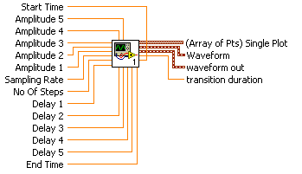  
     
    **start time** is the data element or time value where you want to start acquiring a waveform subset.  
    **end time** is the data element or time value where you want to stop acquiring a waveform subset.  
    **sampling rate** specifies samples per channel per second. If you use an external source for the Sample Clock, set this input to the maximum expected rate of that clock.   
    **No of Steps** specifies the total no. of steps in the waveform.  
    **Amplitude** is the amplitude of the waveform. It is the peak voltage.  
    **Delay** is the period of time for a particular amplitude in the waveform.  
   **transition duration** is the time span from when the waveform crosses the **low ref level** until it crosses the **high ref level** in seconds for a rising transition **polarity**. The measurement starts at the left edge of the waveform and finds all **low ref level** crossings preceding the first **high ref level** crossing. The final **low ref level** crossing is used in the calculation. A rising **polarity** transition duration is known as rise time, and a falling **polarity** transition duration is known as fall time, as shown in the following example:  
    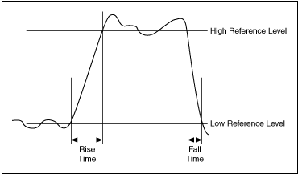  
    **waveform/waveform out**  is the waveform subset.  
    Array of points- Single plot X-Y graph.
2. Sub VI for fetching the parameters from the database based on corresponding test name chosen by the user.  
   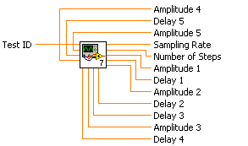  
    **sampling rate** specifies samples per channel per second. If you use an external source for the Sample Clock, set this input to the maximum expected rate of that clock.   
    **No of Steps** specifies the total no. of steps in the waveform.  
    **Amplitude** is the amplitude of the waveform. It is the peak voltage.  
    **Delay** is the period of time for a particular amplitude in the waveform.  
    **Test ID** specifies the the test name.
3. Sub VI for plotting the frequency response by fetching the parameters from the database corresponding to the test name given by the user.  
   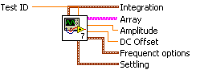  
    **Test ID** specifies the the test name.  
    **Amplitude** is the amplitude of the waveform. It is the peak voltage.  
    **DC Offset** specifies the amplitude of the source in volts peak.  
    **integration time** specifies the time duration, rounded to the next whole cycle, used as the present integration measurement period. The actual integration time used is the maximum of the **integration time**, rounded to the next whole cycle, and the **integration cycles**.  
    **settling time** specifies how much time has to elapse before the measurement begins at the new test frequency. When stepping from one frequency to the next, some devices under test might require a specific amount of settling time before reaching a steady state. The actual settling time is the maximum of **settle time** and **settle cycles**. Allowing the device to reach a steady state helps ensure an accurate response measurement.  
    **Frequency options** specifies the frequency parameters of the sine sweep. Changes to this setting during a sweep do not take effect until the start of the next sweep.

# REFERENCE

* Computer Related programme on C512-LabVIEW programming Basic Course by VSSC.
* en.wikipedia.com
* [www.ni.com](http://www.ni.com)
* The Fundamentals of FFT-Based Signal Analysis and Measurement by Michael Cerna and Audrey F. Harvey.